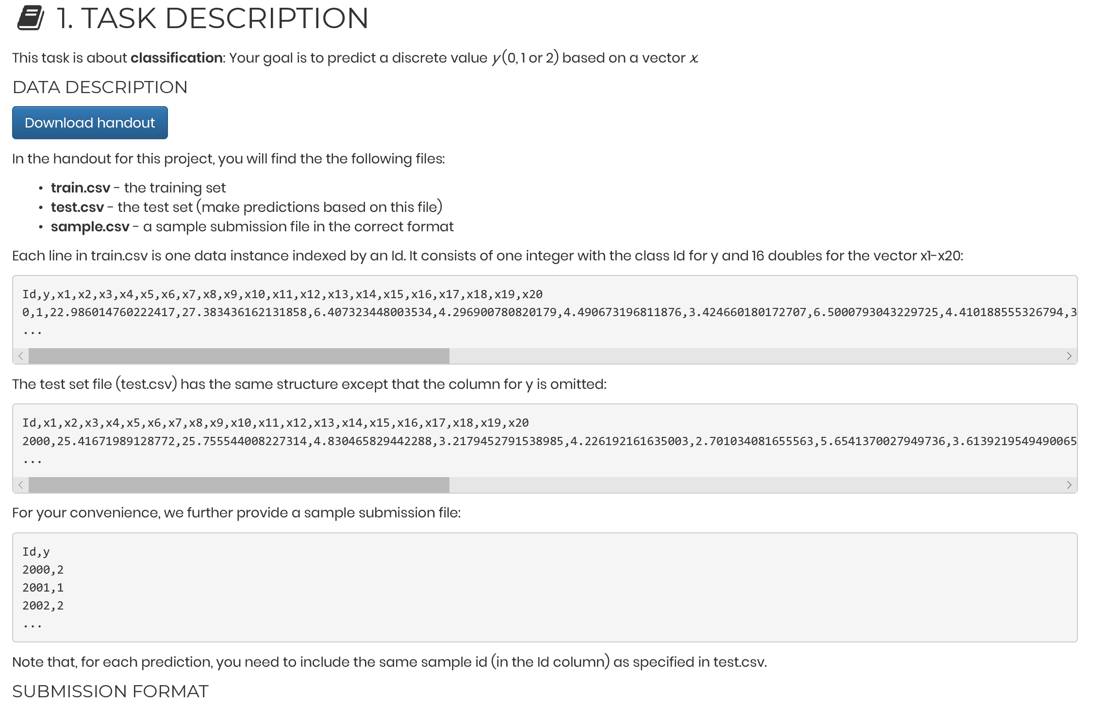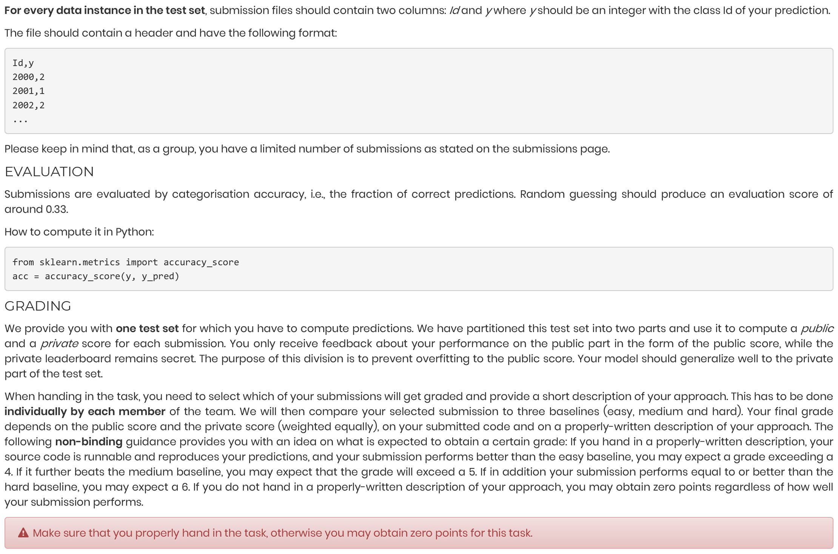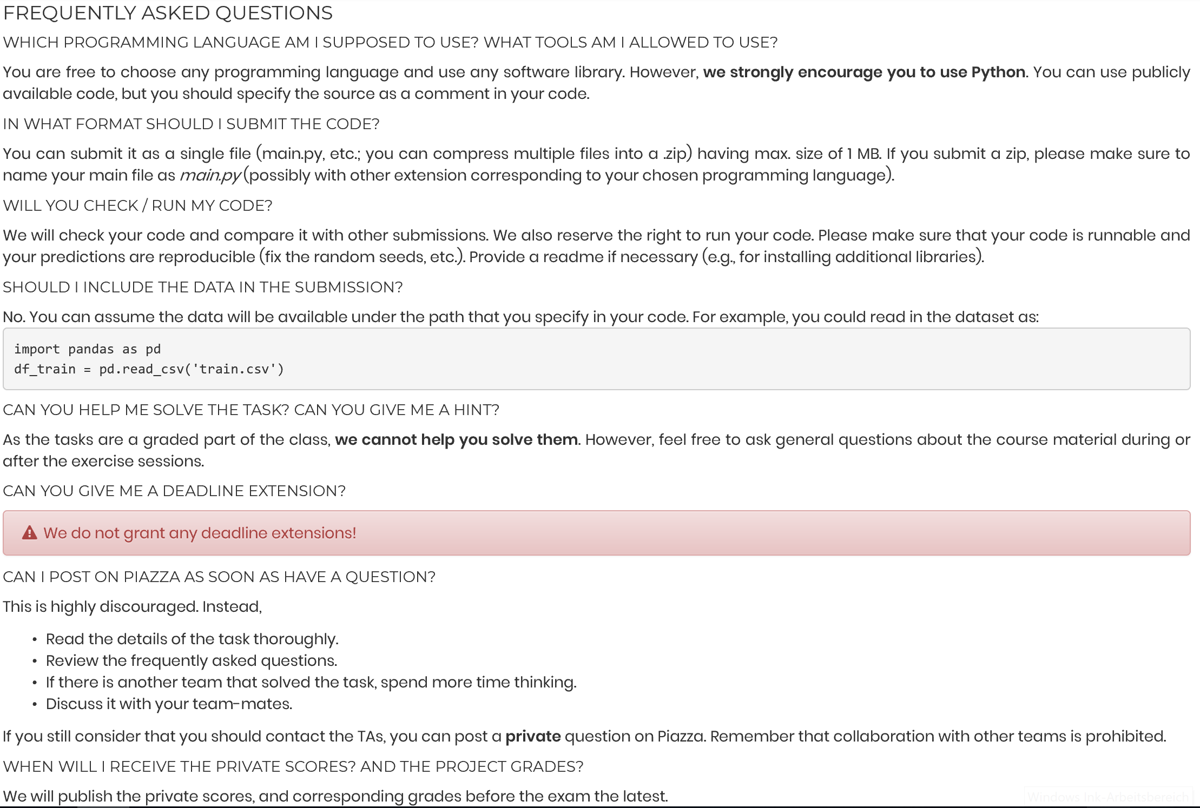

|  |  |  |
| --- | --- | --- |
| **46** | Hard baseline | 0.814814814815 |
| **59** | Medium baseline | 0.779100529101 |
| **60** | Easy baseline | 0.763888888889 |